🏆 FULL FUNNEL COPY — 2-DAY SHOWER SPECIALISTS

🔥 HERO SECTION (Above the Fold)
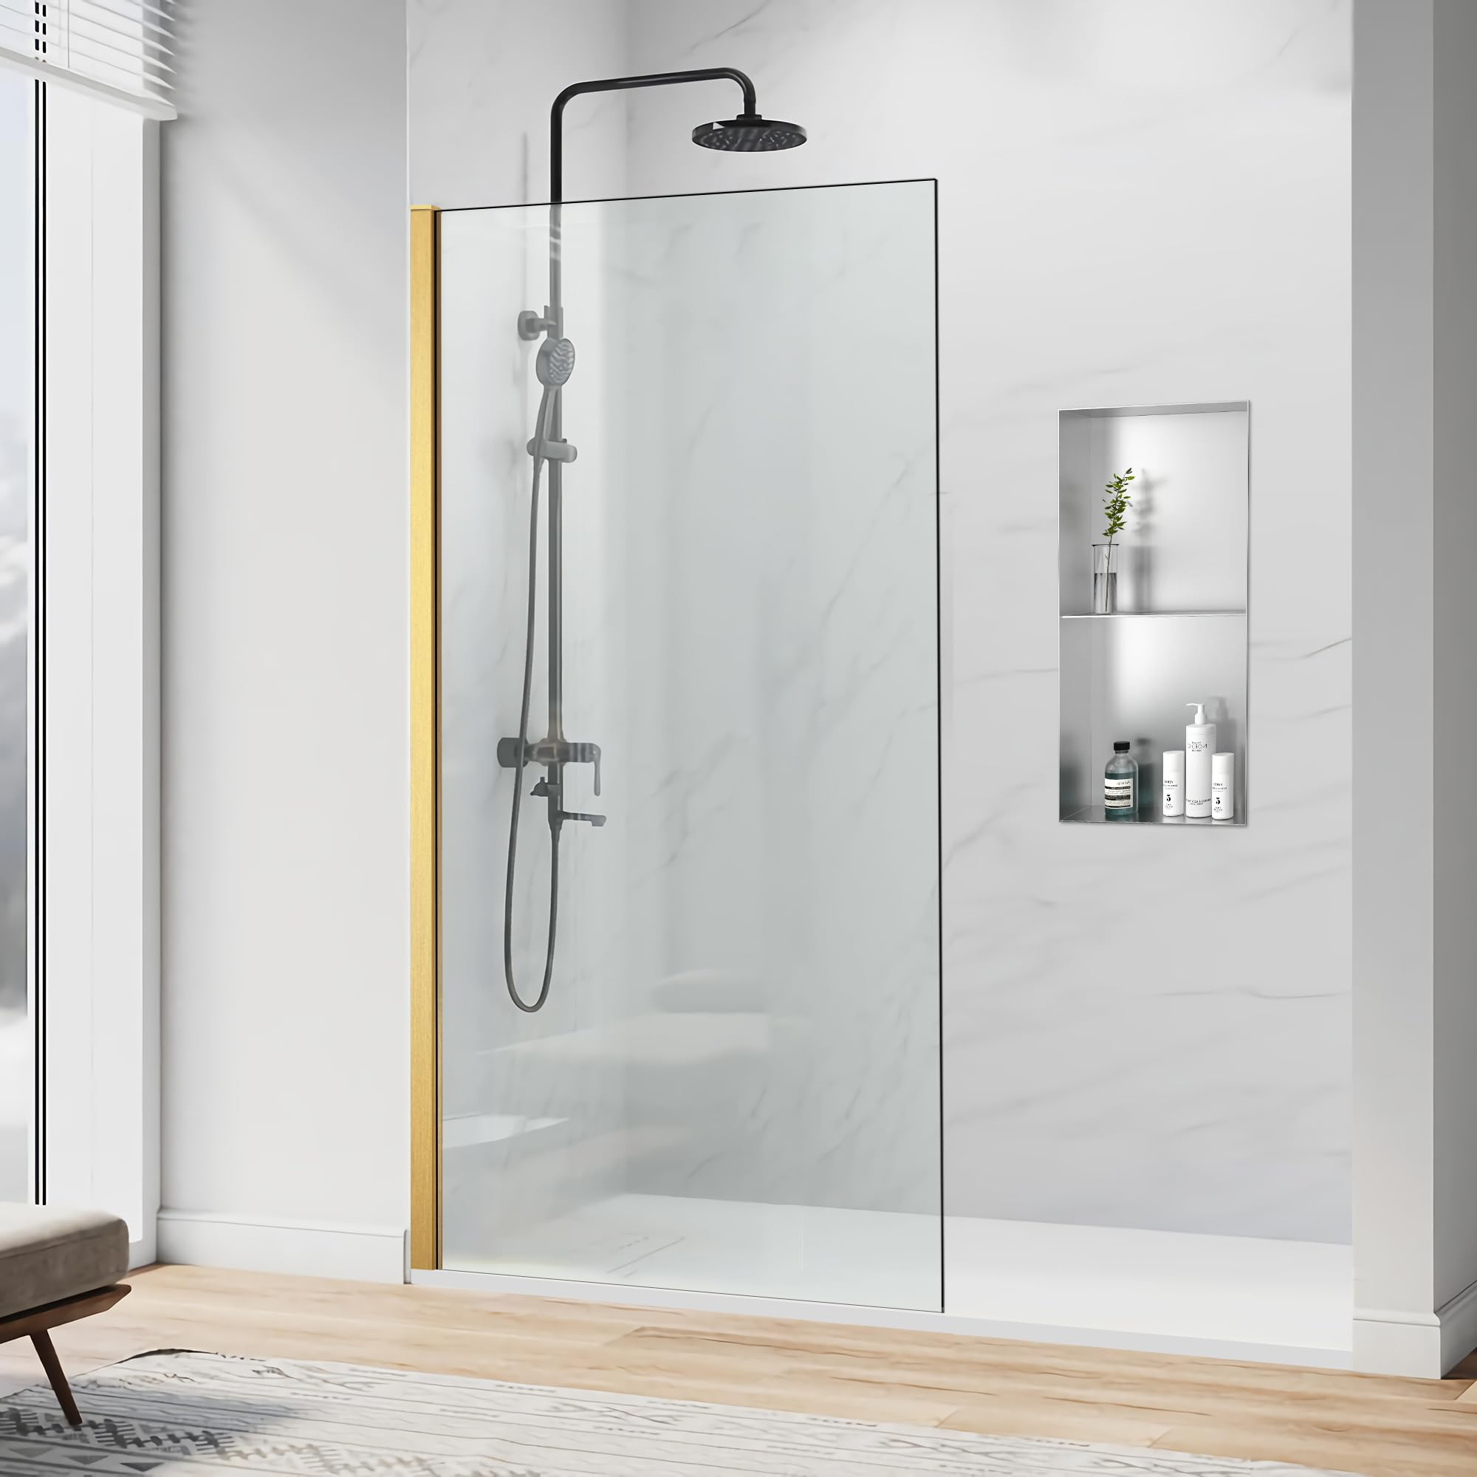
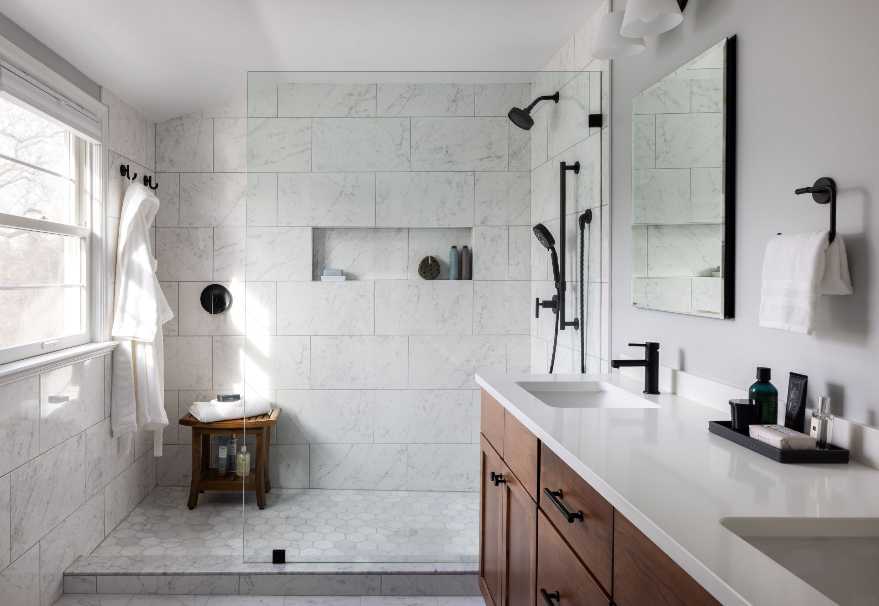
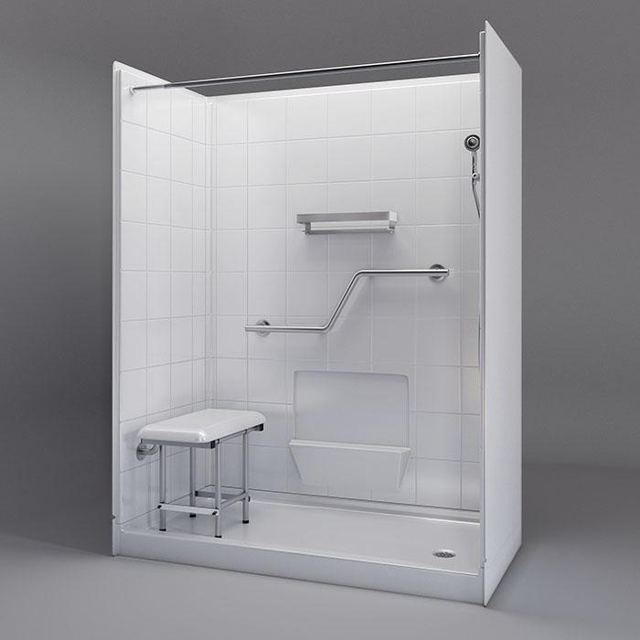
4

HEADLINE

Transform Your Bathroom Into a Beautiful Walk-In Shower in Just 2 Days

SUBHEADLINE
Durable, low-maintenance shower systems professionally installed by local specialists — with no grout to scrub ever again.

PRIMARY CTA BUTTON
Get Your Free In-Home Shower Quote
Small text under button:
✔ Fast installation options available
✔ Financing available for qualified homeowners
✔ Serving the Gulf Coast area

TRUST STRIP
⭐⭐⭐⭐⭐ Rated by Local Homeowners
Licensed & Insured • Professional Installation • Warranty Included

⚠️ PROBLEM → SOLUTION SECTION
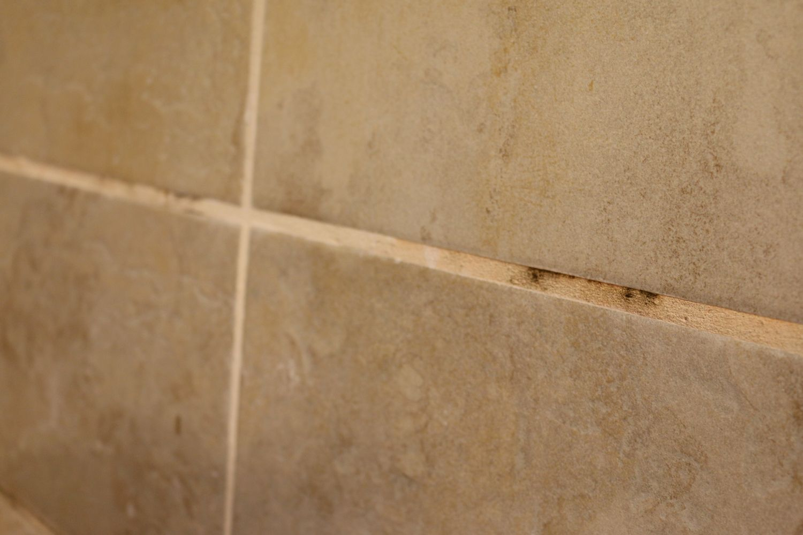
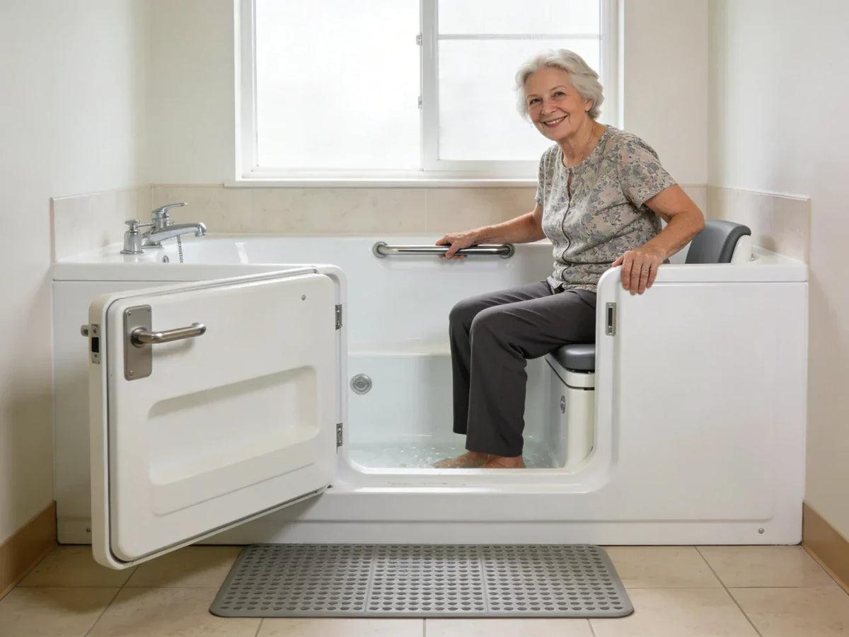
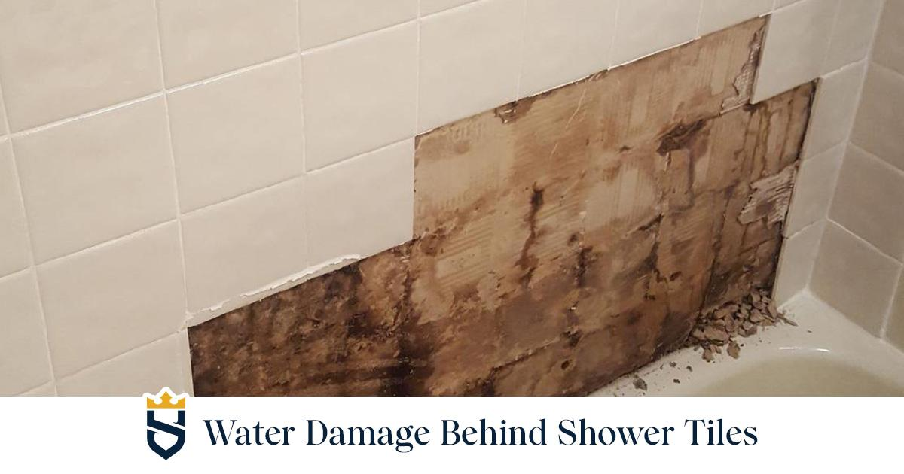
4

Tired of Cleaning Grout, Fighting Mold, or Stepping Over a Tub?
Many Gulf Coast homes still have outdated tile showers or hard-to-access bathtubs that are difficult to clean, unsafe to use, and stuck in the past.
Common problems we solve:
- Moldy grout that never looks clean
- Cracked or outdated tile
- High tub walls that are hard to step over
- Leaks and hidden water damage
- Bathrooms that feel old and uncomfortable

Our modern no-grout shower systems solve these problems permanently.

⭐ BENEFITS SECTION
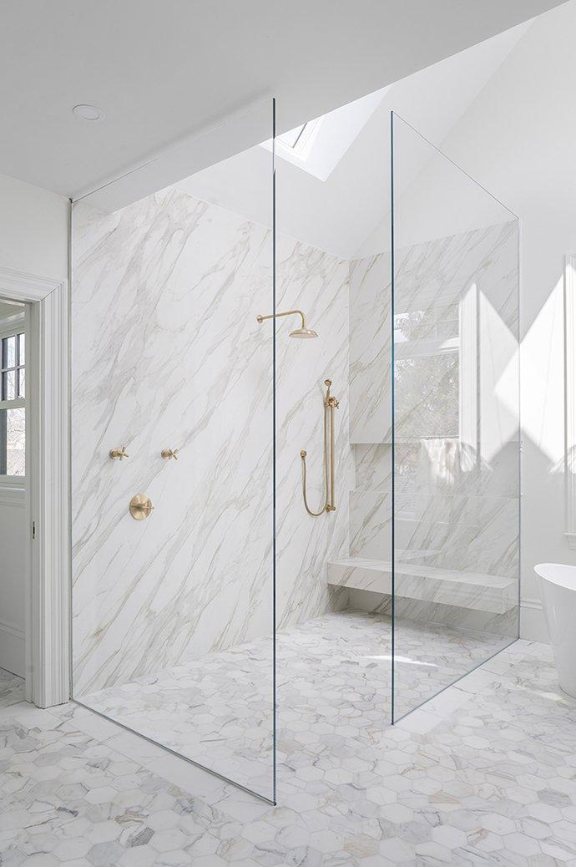
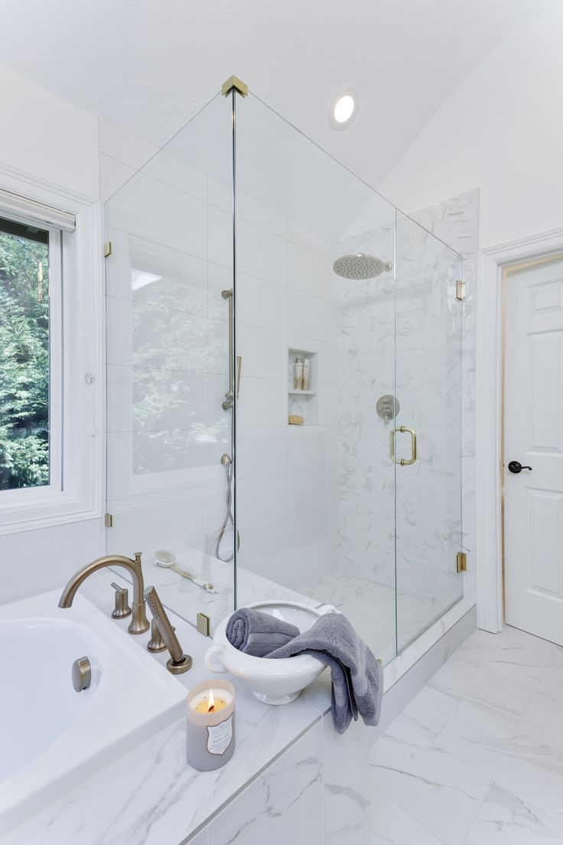
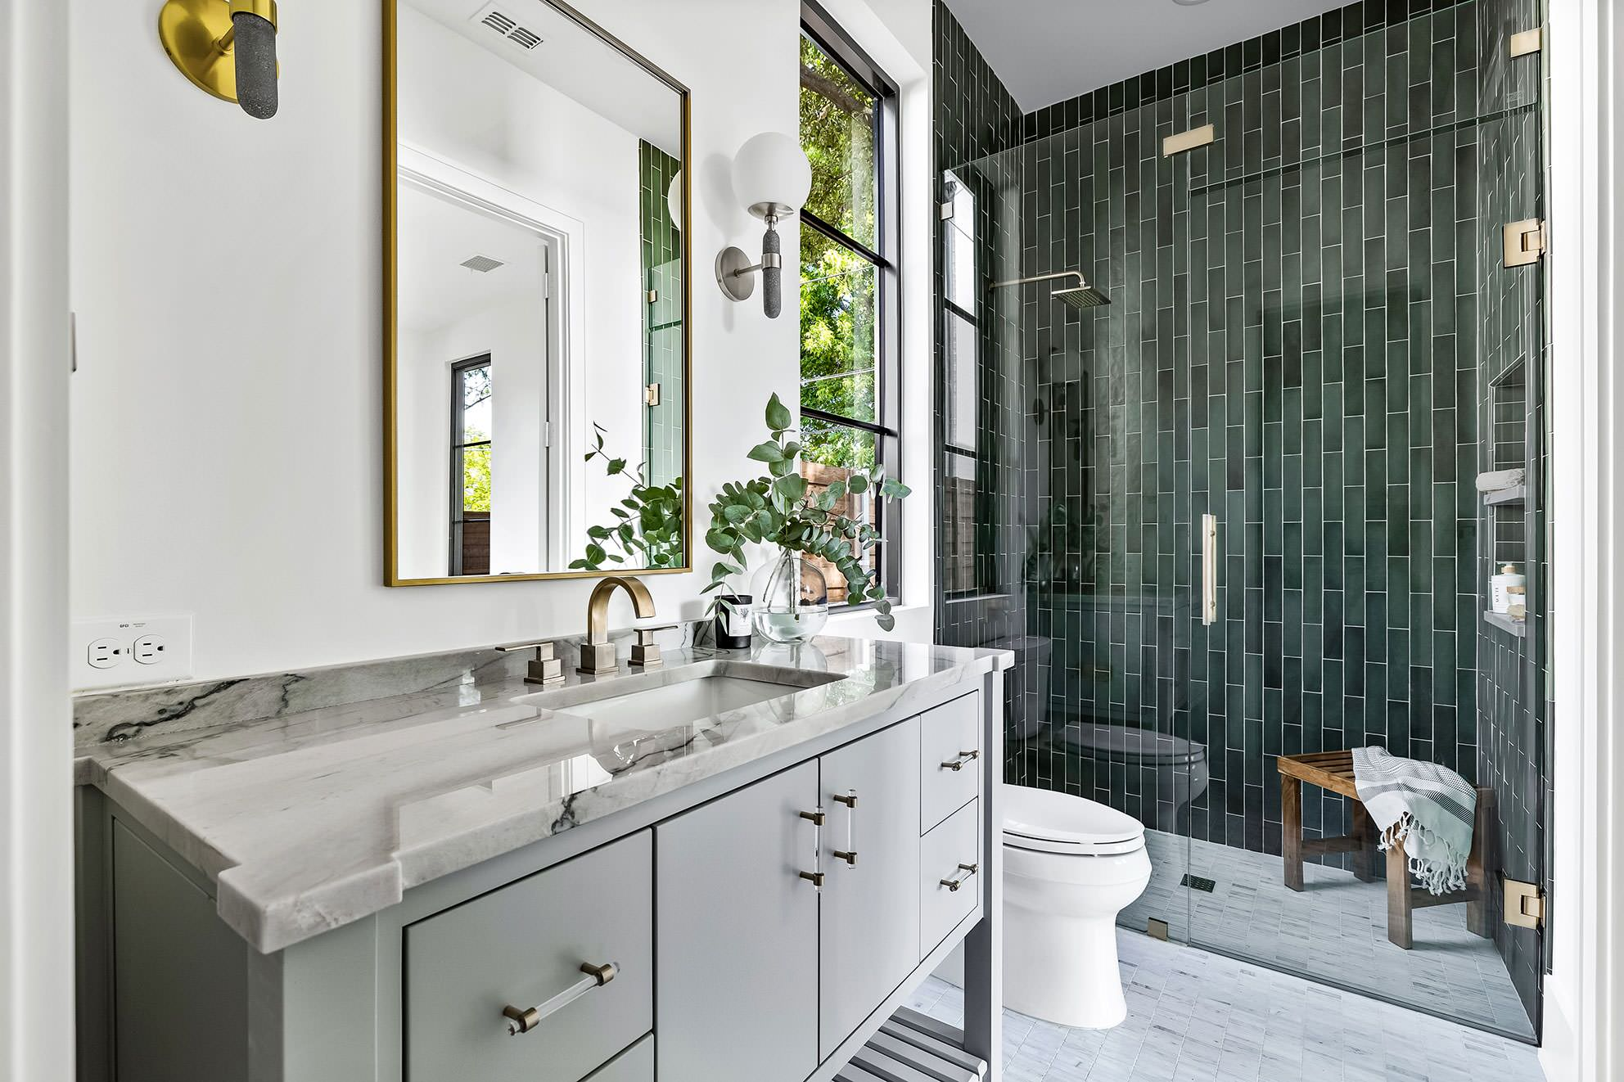
4

Why Homeowners Are Switching to No-Grout Walk-In Showers
✔ Installed in as little as 2 days
✔ No grout lines to scrub — ever
✔ Mold-resistant, easy-clean materials
✔ Safer walk-in entry options available
✔ Beautiful modern designs to match your home
✔ Built for long-term durability
✔ Improves comfort, safety, and resale value

🧩 BEFORE & AFTER TRANSFORMATIONS
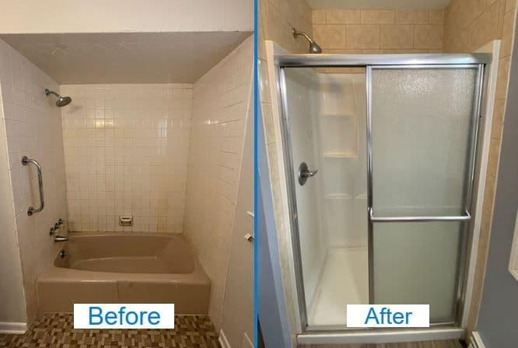
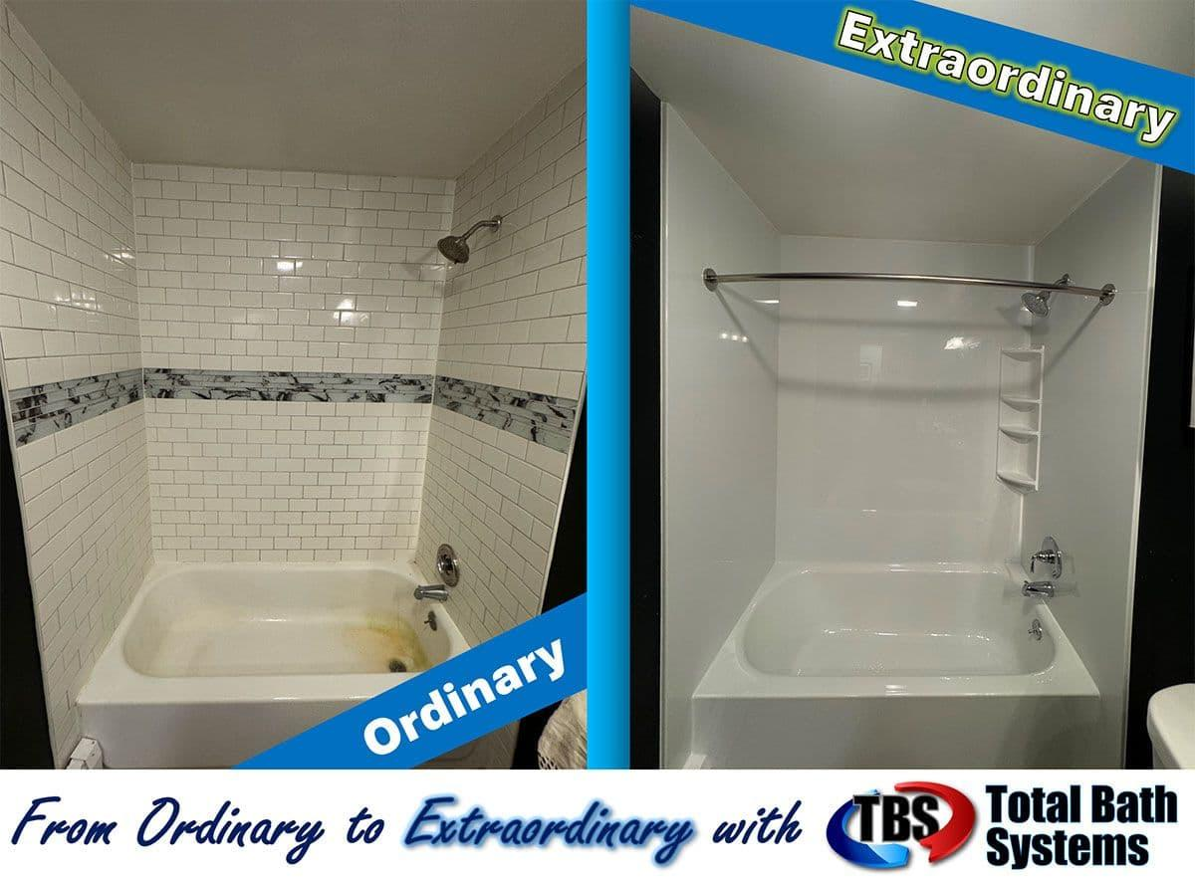
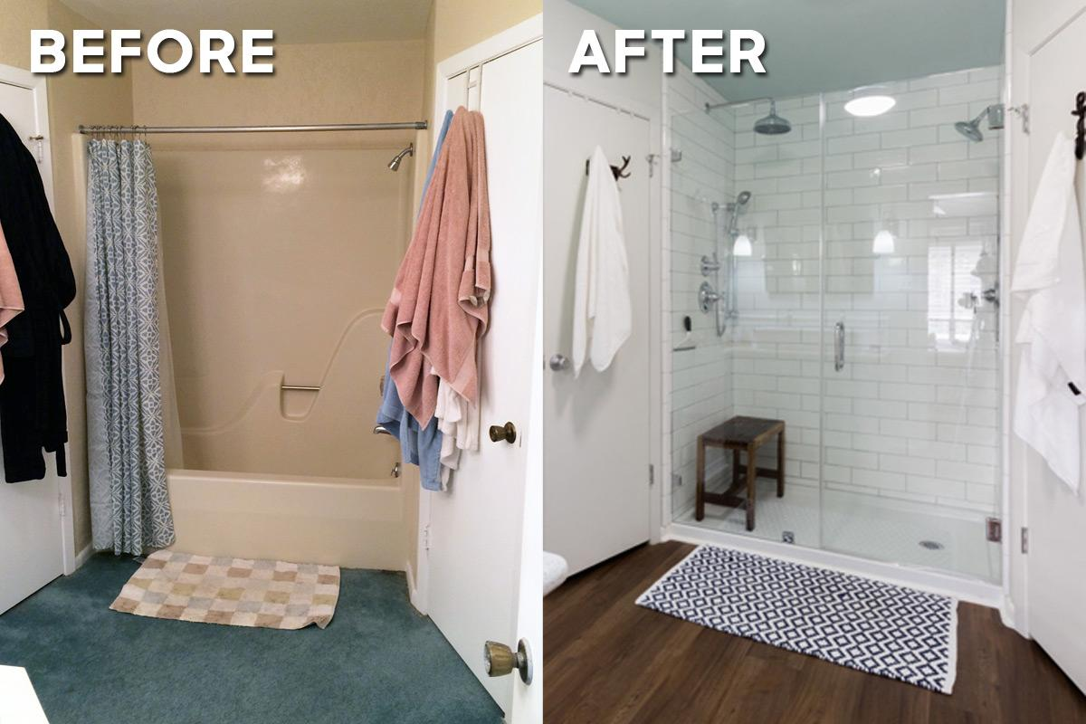
4

Real Transformations by Our Local Team
See how outdated bathrooms become clean, modern walk-in showers in just days — not weeks.
We handle everything:
✔ Removal of old tub or shower
✔ Plumbing adjustments if needed
✔ Installation of new system
✔ Clean jobsite and professional finish

🛡️ TRUST & CREDIBILITY
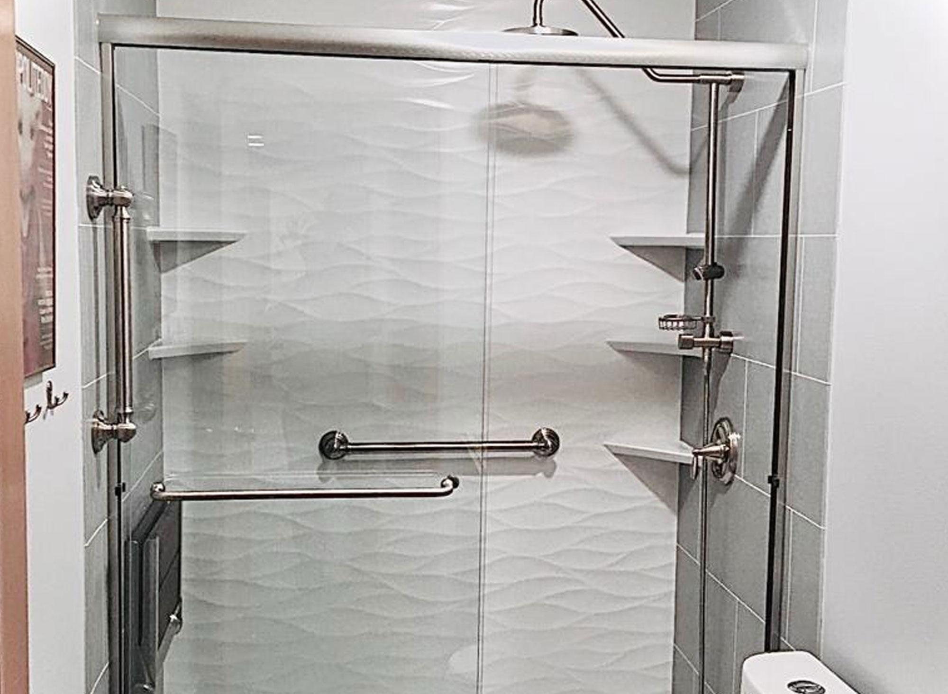

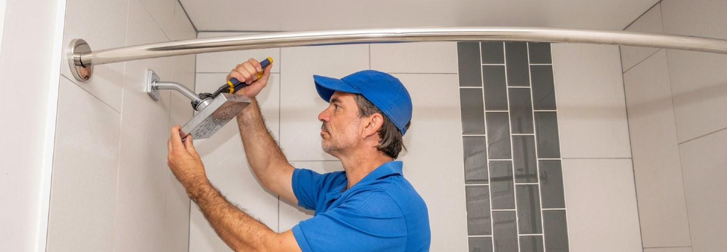
4

Trusted by Homeowners Across the Gulf Coast
Bath Specialists is the bathroom remodeling division of New Construction LLC, proudly serving Gulf Breeze, Pensacola, Navarre, Milton, and surrounding communities.
Why homeowners choose us:
✔ Local company — not a national call center
✔ Experienced professional installers
✔ Licensed & insured
✔ Quality materials designed to last
✔ Respectful crews who treat your home carefully
✔ Clear communication from start to finish

⭐ REVIEWS SECTION

What Your Neighbors Are Saying
⭐⭐⭐⭐⭐
“Our new shower looks incredible and the crew finished faster than we expected.”
⭐⭐⭐⭐⭐
“No more scrubbing grout — this was the best upgrade we’ve done to our home.”
⭐⭐⭐⭐⭐
“Professional, clean, and exactly what they promised.”

💰 SPECIAL OFFER SECTION

Limited-Time Installation Offer
Request your free in-home consultation and ask about:
✔ Current promotional discounts
✔ Upgrade packages
✔ Financing options
✔ Flexible scheduling
Availability is limited each month due to installation capacity.

📅 LEAD FORM SECTION

Get Your Free In-Home Shower Quote
Fill out the form below and a team member will contact you to schedule your consultation.
Form Fields
- Name
- Phone
- Email
- Zip Code
BUTTON:

Schedule My Free Quote
Small text:
We respect your privacy. No spam. No obligation.

☎️ PHONE CTA

Prefer to Speak With Someone Right Now?
Call:

(850) 222-3333
Hours: Mon–Sat 8AM–6PM

